Subject: Submission: Neutrino Masses from the Golden Ratio Lattice

Dear Editors,
I submit for consideration the manuscript "Neutrino Masses from the Golden Ratio Lattice: A Parameter-Free Prediction with Arithmetic Uniqueness" for publication in Journal of Physics G.
This paper extends the golden ratio mass lattice m = m_e * phi^(q/4) to the neutrino sector without additional free parameters. A systematic scan of all integer triples (q1, q2, q3) subject to PDG 2024 neutrino oscillation constraints yields a unique solution within 1 sigma: (q1, q2, q3) = (-149, -146, -134), predicting sum(m_nu) = 71.4 +/- 2.9 meV with chi^2 = 0.58 (2 d.o.f.). The mass ratios satisfy exact algebraic relations: m3/m2 = phi^3, m2/m1 = phi^(3/4). Normal ordering is uniquely selected; inverted ordering admits no solution within 3 sigma.
The base phi is not fitted to neutrino data. It is independently derived as the fundamental unit of Q(sqrt(5)) and the square root of the Mahler measure of the Alexander polynomial of the lepton sector manifold m003. No free parameters were adjusted. The uniqueness of the solution -- a single integer triple satisfying both oscillation constraints within 1 sigma, with no 2 sigma solutions -- is established by exhaustive scan and constitutes the main claim.
The central prediction, sum(m_nu) = 71.4 +/- 2.9 meV, is falsifiable at 3 sigma by CMB-S4, which will reach approximately 30 meV sensitivity. This provides a clear, near-term experimental test.
A preprint is publicly available at SSRN: doi:10.2139/ssrn.6631218. Four companion papers from the same research program are currently under peer review at Results in Physics (RINP-D-26-00327 through -00330), covering the CKM matrix, PMNS matrix, CP violation, and twist spectrum. A paper on the arithmetic structure of the covering tower of the lepton sector manifold was submitted to Experimental Mathematics this week.
This manuscript was previously submitted to Physics Letters B and Physics Open and received desk rejections without scientific review. The scientific content is unchanged.
All scan scripts are available at https://github.com/drmlgentry/hyperbolic-flavor-scan. The author declares no conflicts of interest and received no external funding.
Sincerely,
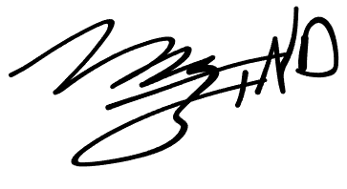

Marvin L. Gentry
Independent Researcher, Seattle WA drmlgentry@protonmail.com
ORCID: 0009-0006-4550-2663

